Requirements and Analysis Document for ooproj-18  
  
Table of Contents

Version: 1.1  
  
Date: 9/4-13

Author: Group 18

This version overrides all previous versions.  
  
**1 Introduction**  
  
 *This section gives a brief overview of the project.*  
  
**1.1 Purpose of application**

Creating a platform game for entertainment. **1.2 General characteristics of application**

The application will be a desktop, stand alone (non-networked), one-player 2D game with graphical user interface for the Windows and Mac platforms.

The game will not be turn based, there will be one player who enters to the far left of a wide map (world) with a chosen character with a chosen weapon. The player must then make his/her way through the world by moving forward (right) or backward (left), jumping, crouching, collecting some form of coins or gems and getting past enemies by either avoiding them or fighting them. There will be obstacles along the way in the form of bumps and dips that have to be avoided by jumping or crouching. The game will end either when the character dies, reaches the end of the map, or when the player himself exits the game from the pause menu.

**1.3 Scope of application**

The game does not support multiplayer mode and it’s not possible to create your own maps, weapons or characters.

**1.4 Objectives and success criteria of the project**

One fully functional map, the ability to choose between two different characters and two different weapons. At least one kind of enemy, one game mode and the options to save and load a game.

**1.5 Definitions, acronyms and abbreviations**

* GUI, graphical user interface.
* Java, platform independent programming language

**2 Requirements**  
  
 *In this section we specify all requirements*  
  
**2.1 Functional requirements**

The player should be able to:

1: Start a new game

a) Select character, character name and weapon.

2: Load a game and continue from where he saved last time he was playing.

3. Play the game and move along to the end of a map to complete the game.

4. Fight monsters. These monsters can “kill” the character, the character will

then either lose a life if it has any left or the game will prompt for the player’s

choice if no lives are left .

5. Pause the game. When this is done a menu will popup, and the player can

choose between these different options:

a) Resuming the game

b) Opening the options menu, including sound, video and control settings.

c) Saving the game

d) Exiting the game

6.Reach the options menu from the start menu.  
  
**2.2 Non-functional requirements**   
  
 *Possible NA (not applicable).*  
  
**2.2.1 Usability**

Our ambitions is that people of all ages and cultures will want to play our finished game. We also want people to be able to learn to play the game reasonably easy no matter what computer knowledge they possess beforehand, this puts a user friendly interface in focus. We want to make a colorful and exciting game with inspiring music in the background. High usability is therefore high priority. The game will be in English, since this is the a good way to reach people from many different cultures.

**2.2.2 Reliability**

NA **2.2.3 Performance**

Any input from the user should move the character without any delay if the move is possible. The map is going to move softly in the background and accompany the player throughout the game.

**2.2.4 Supportability**

The game we are about to create is a computer game. This means that we focus on computer development. Applications for smart phones and tablets are certainly very tempting, but our first step is all computers that supports Java. Therefore the GUI is design for computers. Testing is in high focus and we will regular test all use cases firmly.

**2.2.5 Implementation**

To achieve platform independence the application will use the Java environment. All host must have JRE installed and configured on his/her computer. The user need to install or download the game to computer.

**2.2.6 Packaging and installation**

We don’t yet know how the game will be packaged or installed or what will be asked of the user, though it is likely that we will provide a README-file documenting the installation process once we do know.

**2.2.7 Legal**

We have no interference with any rights or trademarks. **2.3 Application models  
  
2.3.1 Use case model** See Appendix.  
  
**2.3.2 Use cases priority**  
 1. Move

2. Fight

3. Move into collectibles

4. End game

5. Pause

6. Load game

7. Start game

8. Options  
 **2.3.3 Domain model**See appendix.  
**2.3.4 User interface**   
  
 *Text to motivate a picture.*  
  
**2.4 References**

Use case model:

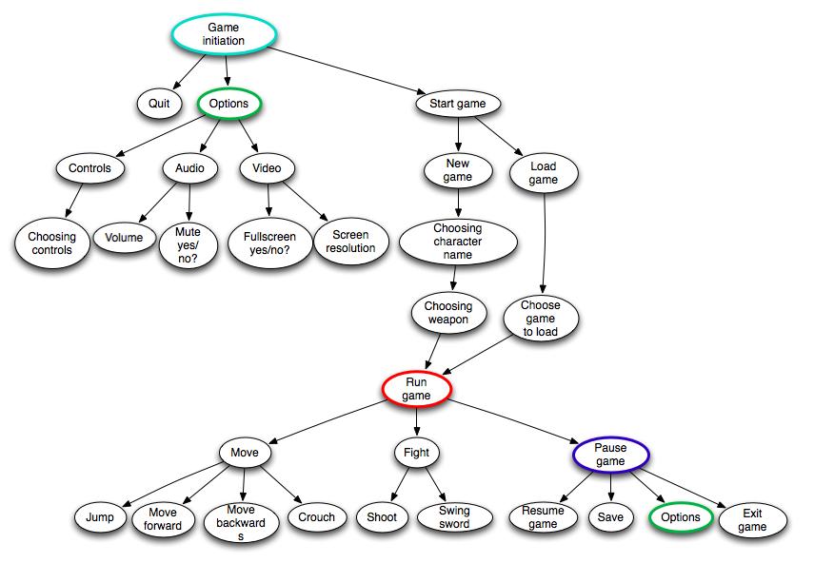

Domain model: 